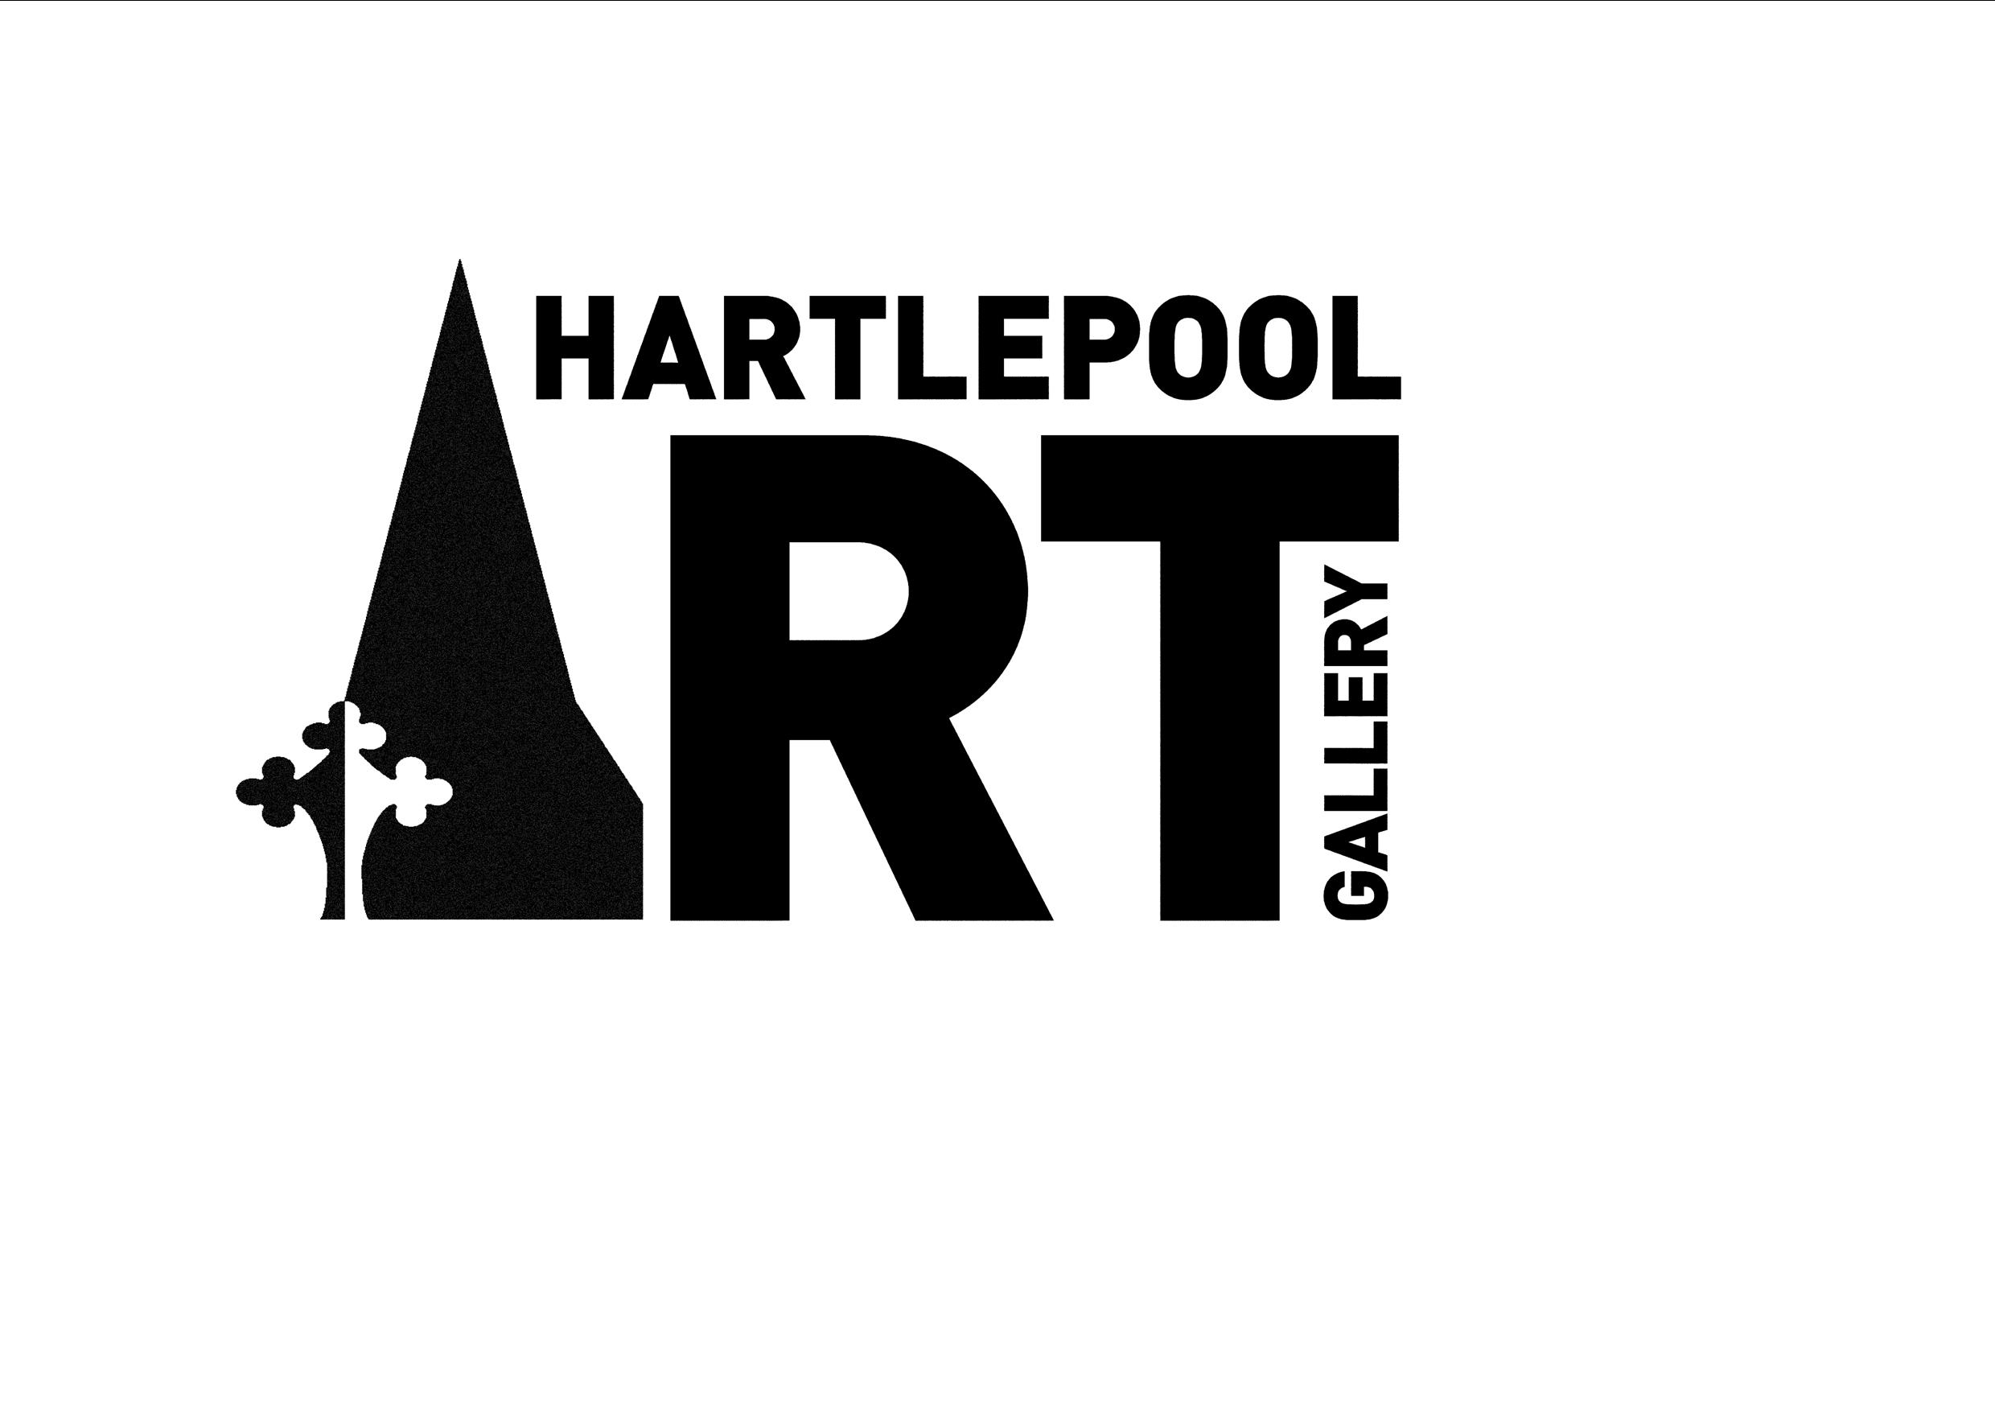

HARTLEPOOL BOROUGH COUNCIL, CULTURAL SERVICES
OPEN CALL EXHIBITION SUBMISSION FORM

Name: | Date:
Are you applying as a solo artist or on behalf of a collective?

If applying on behalf of a collective, please provide details of your collective including the names of each member:

What is the best email address for us to use to contact you?

What is the best telephone number for us to use to contact you?

Please provide us with the best postal address to contact you:

Artist Biography: (please include CV, social media or website address if possible)

Please give details of your artwork, including title, medium, date and measurements:

Please describe how your artwork fits the theme of Resilience:

Include images of your artwork here:

By submitting this form, you agree to the conditions of entry (see below) and declare that you are eligible to enter.

I declare that I am aged 18 years or over. All works submitted have been completed within the past 2 years and are available for the entire exhibition period. If a work is sold during the exhibition period, 35% commission is payable to Hartlepool Art Gallery. If selected, images of my work may be used for press and marketing purposes, and visitors to the exhibition have my permission to include my work(s) in their photographs.

Please return your completed application to HartlepoolGallery@hartlepool.gov.uk

